AXI Data Bus and AXI4 Slave Memory - Handshake protocol

AXI channels
The AXI specification describes a point-to-point protocol between two interfaces: a manager and a subordinate. The following diagram shows the five main channels that each AXI interface uses for communication:

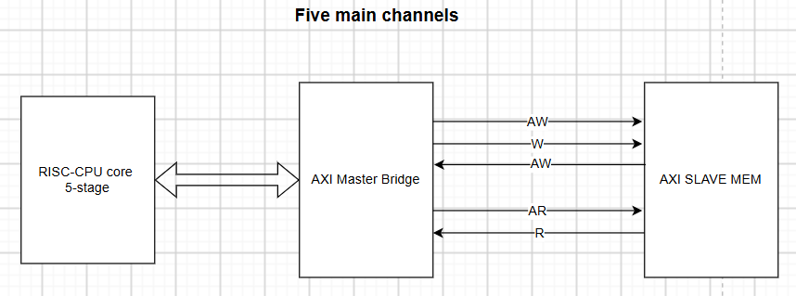
Write operations use the following channels:
• The manager sends an address on the Write Address (AW) channel and transfers data on the Write Data (W) channel to the subordinate.
• The subordinate writes the received data to the specified address. Once the subordinate has completed the write operation, it responds with a message to the manager on the Write Response (B) channel.
Read operations use the following channels:
• The manager sends the address it wants to read on the Read Address (AR) channel.
• The subordinate sends the data from the requested address to the manager on the Read Data (R) channel. The subordinate can also return an error message on the Read Data (R) channel. An error occurs if, for example, the address is not valid, or the data is corrupted, or the access does not have the right security permission.

Below is an explanation of the handshake protocol between the AXI4 Master Bridge and the AXI4 Slave Memory.

Diagram AXI4
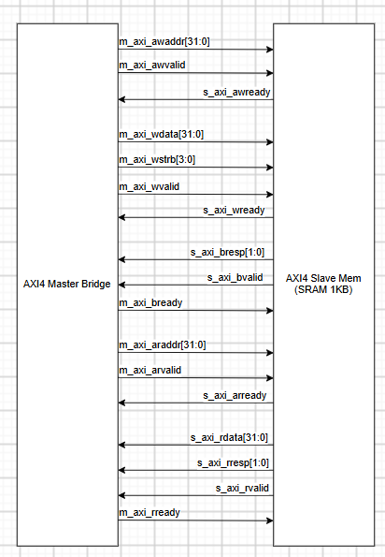

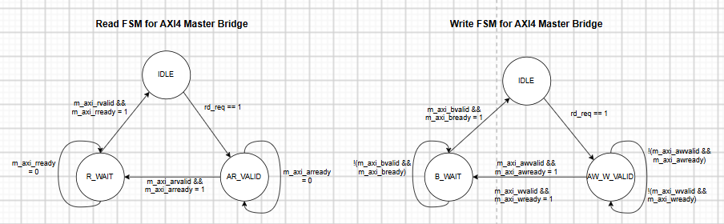

- Read FSM AXI4 Master Bridge
IDLE State:
+ Operation: Default state after reset. Drives all valid signals low.
+ Transition condition: When the CPU issues a read command (rd_req == 1), latch the CPU address (addr) into an internal register and transition to the AR_VALID state.
AR_VALID State (Address Read Valid):
+ Output signals: Assert m_axi_arvalid = 1 and drive the address onto m_axi_araddr.
+ Transition condition: Follows the handshake protocol. Transition occurs only when the slave responds with m_axi_arready == 1. If 0, stay in this state. If 1, transition to R_WAIT.
R_WAIT State (Read Data Wait):
+ Output signals: Assert m_axi_rready = 1 to indicate that the master is ready to receive data from the slave.
+ Transition condition: Wait for m_axi_rvalid == 1 from the slave. When this occurs, immediately latch m_axi_rdata, forward it to the CPU, assert the rvalid flag to the Hazard Unit for one clock cycle, and transition back to IDLE.
- Write FSM AXI4 Master Bridge
Required Registers:
+ aw_done (1-bit): Flag indicating that the Address channel handshake has completed.
+ w_done (1-bit): Flag indicating that the Data (Write) channel handshake has completed.
IDLE State:
+ Logic: Waits for wr_req == 1 from the CPU.
+ Action upon wr_req: Latch the addr and wdata into internal registers. Clear flags: aw_done <= 0 and w_done <= 0. Transition to the AW_W_VALID state.
AW_W_VALID State (Address Write & Write Data Valid):
+ Output logic: m_axi_awvalid is asserted (1) only if aw_done == 0. m_axi_wvalid is asserted (1) only if w_done == 0.
+ Flag update logic: If m_axi_awvalid && m_axi_awready (AW handshake occurs), set aw_done <= 1. If m_axi_wvalid && m_axi_wready (W handshake occurs), set w_done <= 1.
+ Transition condition: When aw_done == 1 AND w_done == 1, de-assert all Valid signals and transition to the B_WAIT state.
B_WAIT State (Write Response Wait):
+ Output logic: Assert m_axi_bready = 1.
+ Transition condition: Wait until m_axi_bvalid && m_axi_bready (B channel handshake occurs).
+ Completion action: Assert the wr_done signal to the CPU (for only 1 clock cycle). Return to IDLE.

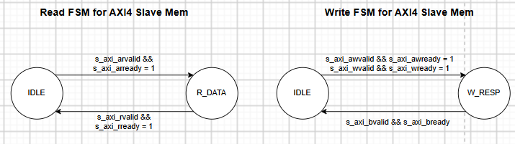

- Read FSM AXI4 Slave Memory
IDLE State (Read Address Wait):
+ Output signals: Assert s_axi_arready = 1 (Slave is always ready to accept a new read address).
+ State transition condition: When s_axi_arvalid && s_axi_arready.
+ Action upon state transition: Latch the address araddr into an internal register. Transition to R_DATA.
R_DATA State (Return Data - R Channel):
+ Output signals: Assert s_axi_rvalid = 1. Drive s_axi_rdata with the data read from the SRAM array at the latched address. Drive s_axi_rresp = 2'b00 (OKAY) if the address is valid; otherwise drive 2'b11 (DECERR).
+ State transition condition: When s_axi_rvalid && s_axi_rready.
+ Action upon state transition: Return to IDLE.
- Write FSM AXI4 Slave Bridge
Internal Flags:
+ aw_latched (1-bit): Set to 1 when the AW channel handshake has completed.
+ w_latched (1-bit): Set to 1 when the W channel handshake has completed.
IDLE State (Address and Data Wait):
+ Output signals: s_axi_awready = ~aw_latched (Always ready to receive the address if not yet latched). s_axi_wready = ~w_latched (Always ready to receive data if not yet latched).
+ Latching actions: If s_axi_awvalid && s_axi_awready: Latch awaddr and set aw_latched <= 1. If s_axi_wvalid && s_axi_wready: Latch wdata, wstrb and set w_latched <= 1.
+ State transition condition: When aw_latched == 1 AND w_latched == 1 (Or when the final-cycle handshake causes both flags to reach 1 simultaneously).
+ Action upon state transition: Perform the write operation of wdata into the SRAM array at address awaddr (if the address is valid). Transition to W_RESP.
W_RESP State (Write Response - B Channel):
+ Output signals: Assert s_axi_bvalid = 1. Drive s_axi_bresp = 2'b00 (OKAY) if the address falls within 0x000 - 0x3FF; otherwise drive 2'b11 (DECERR).
+ State transition condition: When s_axi_bvalid && s_axi_bready.
+ Action upon state transition: Clear both flags: aw_latched <= 0 and w_latched <= 0. Return to W_IDLE.

